**Palmer amaranth adaptation study protocol - 2019**

The objective of this trial is to evaluate the adaptation of Palmer amaranth from Western Nebraska in Illinois and Wisconsin as compared to its place of origin.

The study will be conducted in corn, soybeans and fallow. The area for each crop or fallow will be 30 ft wide (12 rows at 30-inch row spacing) by ~ 35 ft long (please leave at least 5 ft of crop/fallow from the first and last Palmer plants within a plot).

Other than glyphosate, liberty or another contact product sprayed prior to Palmer amaranth plants are transplanted, ***no herbicides should be used in the plot area.*** The plots will be kept weed-free by hand-pulling or hoeing the undesired weeds.

**Soybeans:**

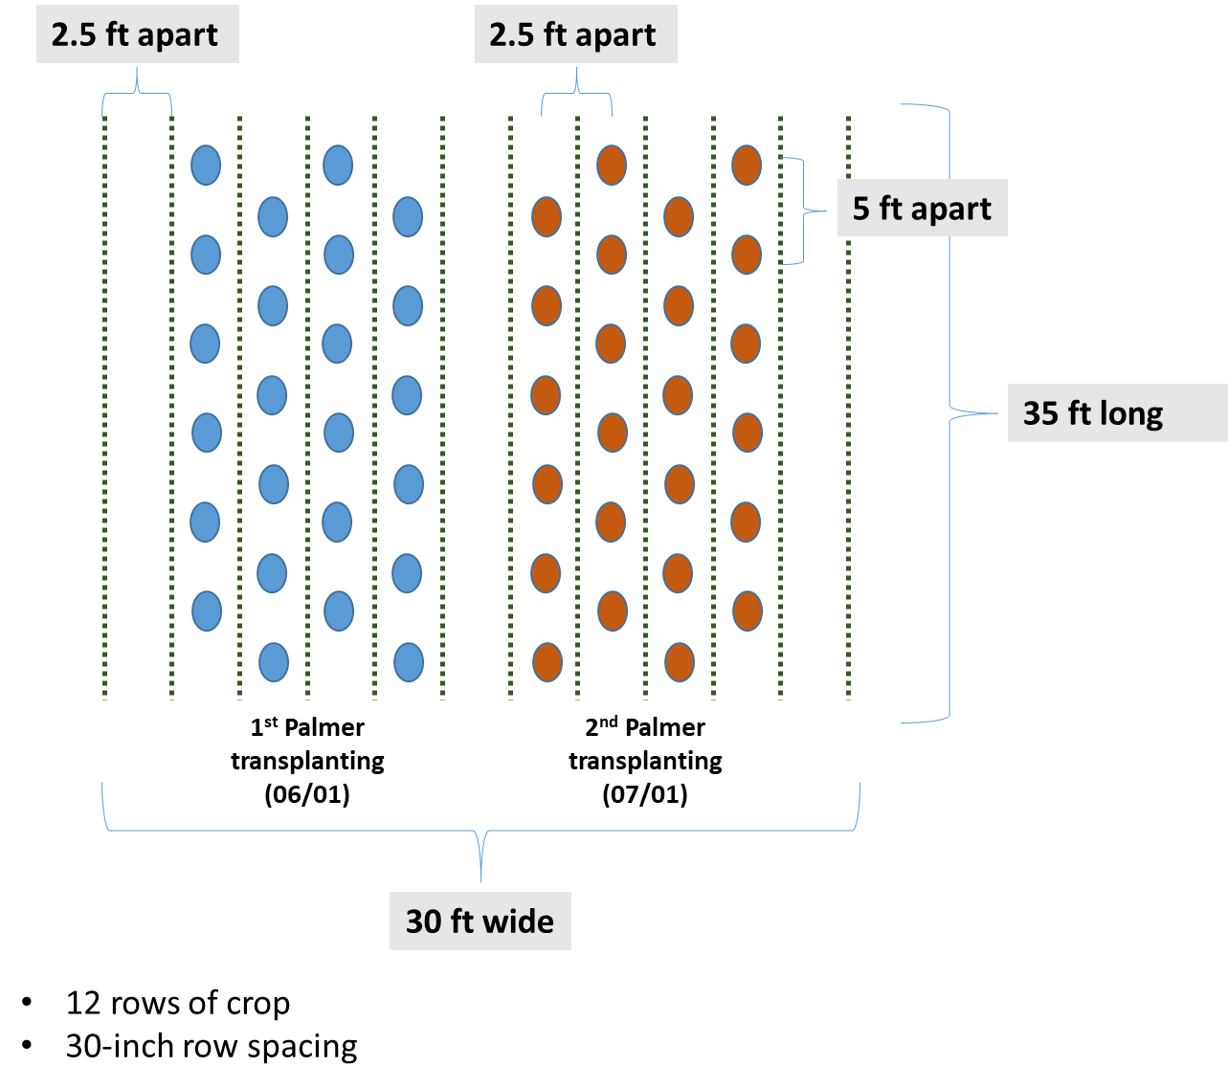

**Corn:**

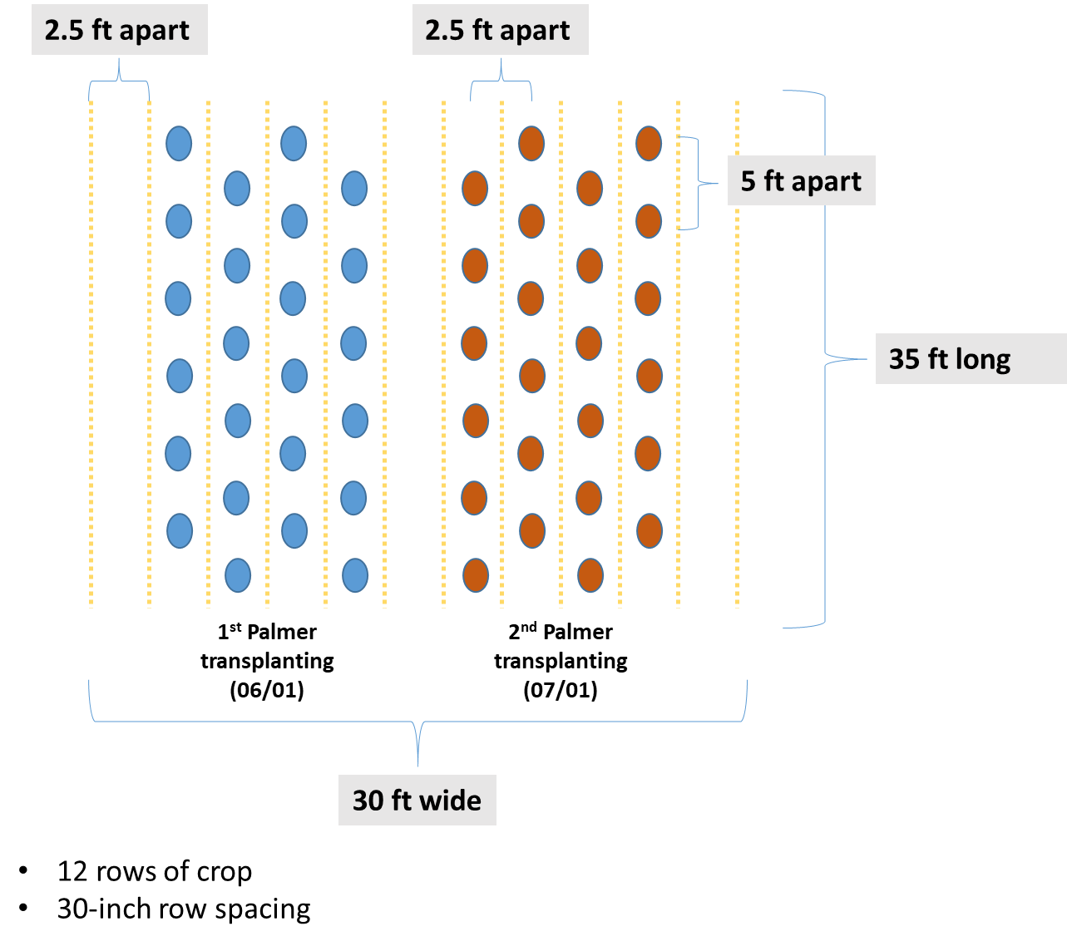

**Fallow:**

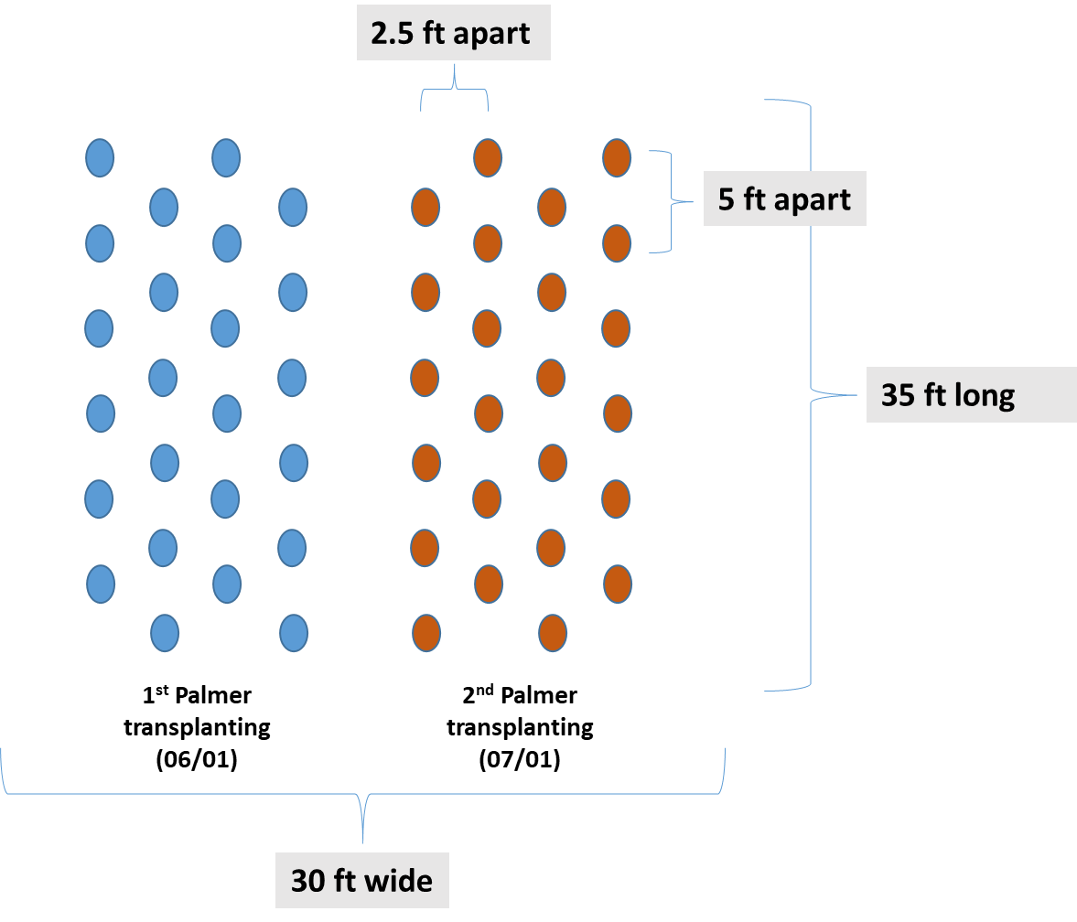

**Procedures:**

1. Palmer amaranth seeds will be placed to germinate in petri dish or plastic pots/trays
2. After emerged, 2 seedlings with 1 true leaf will be transplanted to 3.5-inch square pots filled with potting mix.
3. When Palmer amaranth plants are at the 3-4 leaf stage, they will be transplanted to the field. Dig a hole with the pot size and transfer the whole pot content to the field (potting mix + plant). Lightly water the area surrounding plants after transplanting. Record the crop stage at transplanting. There will be 2 transplanting times: early **(June 1st**) and late **(July 1st)**. 24 pots/crop x 3 crops = 72 pots + 8 extra = 80 pots will be necessary for each planting time.

I anticipate it will take approximately 3-4 weeks from germinating to reaching the 3-4 leaf stage in the greenhouse.

1. One week after transplanting, if both plants on each spot are alive, eliminate one. If both plants are dead, transplant a new extra one from the same cohort that should still be in the greenhouse (extra pots).

Data collection:

* Record the date when plants flower (will soon share more information on that)
* **At flowering, measure plant height and then clip them at the soil surface and record fresh and dry weights.**
* Inspect and eliminate any regrowth in the study area to prevent Palmer amaranth establishment at all costs.

The soybean, corn and fallow plots can be within the same area or in adjacent fields.

Record cultural practices adopted (e.g., tillage, planting time, crop cultivar/hybrid, fertilizers, etc.)

Use standard cultural practices for your region

Collect soil sample from 0-8 inches and analyze for NPK, pH, OM, and % clay, silt and sand. One sample per site if crops are in the same field; multiple samples if crops are in different fields.